*A project report on*

**FOREST COMBUSTION RECOGNITION WITH AI USING CONVOLUTION NEURAL NETWORKS (CNN)**

*Submitted in partial fulfillment for the award of the degree of*

**Integrated MTech Software Engineering**

*by*

**K. Jahnavi (17MIS7059)**



**AMARAVATI**

**VIT-AP UNIVERSITY**

JUNE,2020

**CERTIFICATE**

This is to certify that the thesis entitled “FOREST COMBUSTION RECOGNITION WITH AI USING CONVOLUTION NEURAL NETWORKS (CNN)” submitted by K.Jahnavi(17MIS7059) VITAP, for the award of the Summer Internship for the bonafide work carried out by him/her under my supervision.

The contents of this report have not been submitted and will not be submitted either in part or in full, for the award of any other degree or diploma in this institute or  
any other institute or university. The Project report fulfils the requirements and regulations of  
VIT-AP and in my opinion meets the necessary standards for submission.

**Signature of the Guide**



**CERTIFICATE BY THE EXTERNAL GUIDE**

This is to certify that the project report entitled “**FOREST COMBUSTION RECOGNITION WITH AI USING CONVOLUTION NEURAL NETWORKS (CNN)**” submitted by **K.Jahnavi** (**17MIS7059**) to VIT-AP in partial fulfillment of the requirement for the award of the degree of Integrated Mtech Software Engineering for the bonafide work carried out by him/her under my guidance. The project fulfill the requirements as per the regulations of this Institute and in my opinion meets the necessary standards for submission. The contents of this report have not been submitted and will not be submitted either in part or in full, for the award of any other degree or diploma in this institute or any other institute or university.



(Nagarjuna Madluri)

Signature of the External Supervisor

**K. Jahnavi**

**ABSTRACT**

This project is aimed at the areas where the fire combustion takes place to save the wildlife animals and people situated around. A large forest fire causes a serious impact on the environment, determining its future for decades. Prevention of forest fires is one of today's most important tasks as well as appropriate preparedness for effective fighting against them. To do so, it is vital to have detailed knowledge on AI, deep learning techniques (CNN) to visualize/recognize whether the forests are with fire or without fire through the images which we give the model to predict.

***i***

**ACKNOWLEDGEMENT**

It is my pleasure to express with deep sense of gratitude to Prof. Hari Kishan Kondaveeti, VIT-AP, for his constant guidance, continual encouragement, understanding; more than all, he taught me patience in my Endeavor. My association with him / her is not confined to academics only, but it is a great opportunity on my part of work with an intellectual and expert in the field of coding.

I would like to express my gratitude Dr. G. Viswanathan, MR. G. V. Selvam, MS. Kadhambari S. Viswanathan, Dr. D. Subhakar, and Dr. Hari Seetha, Dean of School of Computer Science & Engineering, for providing with an environment to work in and for his inspiration during the tenure of the course.

In jubilant mood I express ingeniously my whole-hearted thanks to *Dr. D*Sumathi, Associate Professor, all teaching staff and members working as limbs of our university for their not-self-centered enthusiasm coupled with timely encouragements showered on me with zeal, which prompted the acquirement of the requisite knowledge to finalize my course study successfully. I would like to thank my parents for their support.

It is indeed a pleasure to thank my friends who persuaded and encouraged me to take up and complete this task. At last but not least, I express my gratitude and appreciation to all those who have helped me directly or indirectly toward the successful completion of this project.

Place: AMARAVATHI

Date: 11.07.2020 **K. Jahnavi**

***ii***

**CONTENTS**

**CONTENTS**  iii

**LIST OF FIGURES** v

**LIST OF TABLES** vi

**LIST OF ACRONYMS** vii

**CHAPTER 1**

**INTRODUCTION**

* 1. INTRODUCTION 1
  2. OVERVIEW .1

1.3 CHALLENGES ………………………. 2

1.4 PROJECT STATEMENT ………2

1.5 OBJECTIVES ………………………………………………………...……………..2

1.6 SCOPE OF THE PROJECT 2

**CHAPTER 2**

**BACKGROUND**

2.1 INTRODUCTION…………………………………………………………………..3

2.2 LITERATURE SURVEY …………………………………………………………..3

2.2.1 EXISTING PROBLEM…………………………………….………………….3

2.2.2 PROPOSED SOLUTION………………………………………………….…..3

2.3 DATASET……………………………………..………………………………….…4-5

***iii***

2.4 METHODOLOGY…………….……………………………………………….….5-6

2.4.1 IMPORTING THE BUILDING LIBRARIES.………………………….……7

2.4.2 INITIALIZE THE MODEL…………………….……………………….……7

2.4.3 ADDING CNN AND DENSE LAYERS …………………………………...8-9

2.4.4 IMAGE PREPOROCESSING ………………………………………………10

2.4.5 IMPORT DATASET………………………………………………………10-11

2.4.6 TRAINING AND TESTING THE MODEL ……...………………………11-13

2.4.7 EXPERIMENTAL RESULTS……………………………………………..14-15

2.5 BUILDING USER INTERFACE…………………………………………………16-19

2.5.1 PREDICTION………………………………………………………….……20-23

**CHAPTER 3**

**THEORITICAL ANALYSIS**

3.1 BLOCK DIAGRAM………………………………………………………………………………………24

3.2 HARDWARE AND SOFTWARE DESIGNING………………………………………………..24

APPENDIX

CODE…………………………………………………….………………………….25-35

**CHAPTER 4**

4.1 CONCLUSION……………………………………………………………………..36

4.2 FUTURE WORK…………….……………..………………………………………36

4.3 REFERENCES……………………………………………………………………...36

***iv***

**LIST OF FIGURES**

Fig1: Forest With Fire…………………………………………………………………4

Fig2: Forest Without Fire…..…………………………………………………………5

Fig3: Flow Chart………..…..…………………………………………………………6

Fig4: Imported Libraries………………………………………………………………7

Fig5: Model Initialization……………………………………………………………..7

Fig6: Convolution, Max Polling, Flatten Layers ……………………………………..8

Fig7: Applying Dense Layers…………………………………………………………9

Fig8: Compile…………………………………………………………………………9

Fig9: Image Preprocessing………………………………………………………..….10

Fig10: Imported Dataset……………………………………………………………...10

Fig11: Training and Evaluating the model………………………………………..11-13

Fig12: Loading model and image ……………………………………………………14

Fig13: Without fire- Alarm off……………………………………………………….15

Fig14: With fire- Alarm on…………………………………………………………...15

Fig15: Anaconda Prompt……………………………………………………………..16

Fig16: Folder of Flask model ………………………………………………………...17

Fig17: Flask code………………………………………………………...……….......18

Fig18: Html code…………………………………………………...…………….......18

Fig19: Developed UI………………………………………….…………………........20

Fig20: Prediction of forest with fire……………………..………………………........21

Fig21:Predicition of forest withoutfire…………………… ……….……………........21

Fig 22 : anaconda prompt – OpenCV…………………………………………………22

Fig 23 : predicted class – without fire…………………………………………………23

Fig 24 : predicted class – with fire…………………………………………………….23

Fig 25 : block diagram…………………………………………………………………24

**v**

**LIST OF TABLES**

Fig3: Flowchart……………………………………………………………………6

Fig 25 : block diagram……………………………………………………………24

***vi***

**LIST OF ACRONYMS**

AI Artificial Intelligence

CNN Convolution Neural Networks

ANN Artificial Neural Networks

OpenCV  Open Source Computer Vision Library

***vii***

**Chapter 1**

**INTRODUCTION**

**1.1 INTRODUCTION**

Forest fires are a major environmental issue, creating economic and ecological damage while endangering human lives. There are typically about 100,000 wildfires in the United States every year. Over 9 million acres of land have been destroyed due to treacherous wildfires. It is difficult to predict and detect Forest Fire in a sparsely populated forest area and it is more difficult if the prediction is done using ground based methods like Camera or Video Based approach. Satellites can be an important source of data prior to and also during the Fire due to its reliability and efficiency. Forest fires destroy a total area of 3.5 to 4.5 million km. Here we are going to train the model in such a way that if you give an image/picture of the forest it will detect whether the forest is with fire or without fire. And if it recognizes the fire picture it puts on an alarm sound. This helps us to find out the forest combustion in an easy way by staying even at home.

* 1. **OVERVIEW**

Environment is major wealth of our country. Forests provide enormous material goods and environmental services. They are useful for industry as well as rural economic growth. At the same time, when the forest is under fire it emits lot of carbon dioxide leads to climate change and global warming. So the forest fire has to be detected at earlier stage. For example, recently we have seen forest fires in Australia. Approximately 18,636,079 hectares (46,050,750 acres) off forest area had undergone combustion. So, due to isolation, inaccessibility, tough weather, shortage of frontier staff, the early finding of forest fire is a difficult task we have developed a model to detect forest fire combustion. Anyways to do it manually we need lot of man power so to overcome that we are implementing CNN (Convolutional Neural Network) Model, which is a deep learning technique to predict the fire in forest.

**1**

**1.3 CHALLENGES**

* This model should be able to accurately identify/recognize forest combustion. If we give images it should predict whether the image is with fire or without fire. The approach is being developed for further advance to support automated detection of fire in real-time. For example by using mobile devices, drones, sensors with Arduino etc...
* Should be supported in any kind of weather situations.
* Manually it is so difficult to go and search around the forest where the fire catches so, we need to implement in the form of software.

**1.4 PROJECT STATEMENT**

By this project we are able to meet the main objectives of the client. The existing system does not make any detection of the fire of its own unless we place/have any sensors to identify them so, human has to waste their time to go and check around the forest. But new system which we are going to develop can predict the fire by using images developed by CNN (analyzing visual imagery). This can be very tedious and time consuming, resulting in users to refraining from using these applications for long periods of time. So, by using deep learning technique - CNN we are able to achieve the goal of our project.

**1.5 OBJECTIVES**

The main objective of our project is to control forest fires and strengthen the forest protection and create a user-friendly environment where anyone should be able to use. Also, they should be able to access the software from anywhere and anytime.

* 1. **SCOPE OF THE PROJECT**

The scope of Forest Combustion Recognition is to save Environment (plants & trees), wildlife, tribal people who live around the forest. It can work irrespective of weather conditions and can be used wherever and whenever we want. This project is done by using AI by implementing deep learning techniques.

**2**

**Chapter-2**

**BACKGROUND**

**2.1 INTRODUCTION**

The main initiate of this project is to reduce manual work. To develop this type of project the person should have well knowledge of python using deep learning techniques mainly convolution neural networks because the approach used for our project is CNN. We have taken two scenarios of “with fire , without fire” and able to achieve/predict them using this technique.

**2.2 LITERATURE SURVEY**

**2.2.1 EXISTING PROBLEM**

Now days there are lot of existing systems for forest combustion recognition, one system differ from another systems, few of them doesn’t detect properly whether fire is present or not . Some systems are developed based on IOT Applications, we have to keep that hardware system in forest. Due to weather conditions, like when rainfalls few systems may be destroyed. So, then it will be difficult to detect. Then our model comes into existence, works irrespective of the weather conditions.

**2.2.2 PROPOSED SOLUTION**

The proposed Forest Fire Prediction model is based on neural networks(CNN) incorporated to an alert system. The developmental approach of the proposed system includes two modules:

* Forest Fire Identification: Identification of fire affected areas.
* Forest Fire Management: Remedial measures for Forest Fire is all about detecting where the fire initiated in the forest.

In our proposed system we made an effort to classify the images of forest with fire and forest without fire for further using convolution neural networks (CNNs).Since the CNNs are capable of handling a large amount of data and can estimate the features automatically, they have been utilized for the task of forest combustion recognition. The forest dataset of train and test has been selected as the working GUI for this approach. Here we select a sample of few images (approx..100) with fire and without fire segregate them into train and test and model predicts them perfectly depending upon accuracy.

**3**

**2.3 DATASET**

Images of different resolutions and sizes were obtained from many resources, including photos taken by mobile phone, a hand-held camera, obtained from the internet. These images were rescale into 255 × 255 to increase the size of our dataset producing a total number of 200 images in our dataset. The data was labelled into two main categories:

1. Forest With Fire
2. Forest Without Fire.

The total number of images used as training data was 140 - forest with fire (70 images), forest without fire (70 images). For validation set, 30% of testing data (60 images out of 200 images) were selected.

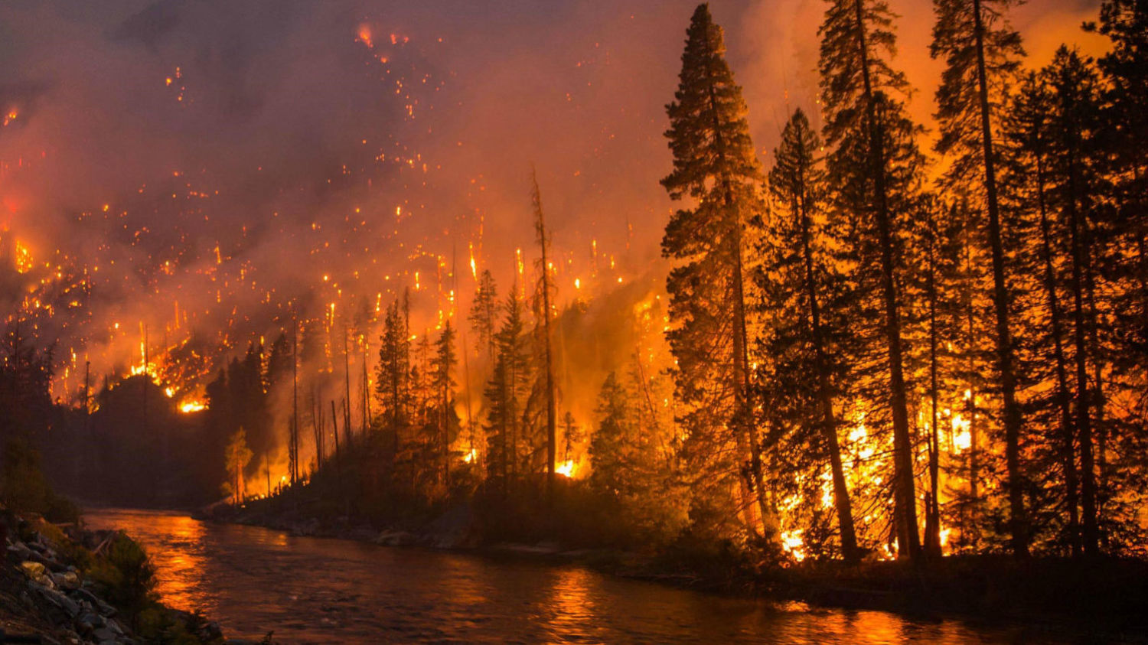

**Fig 1 : Forest with fire**

**4**

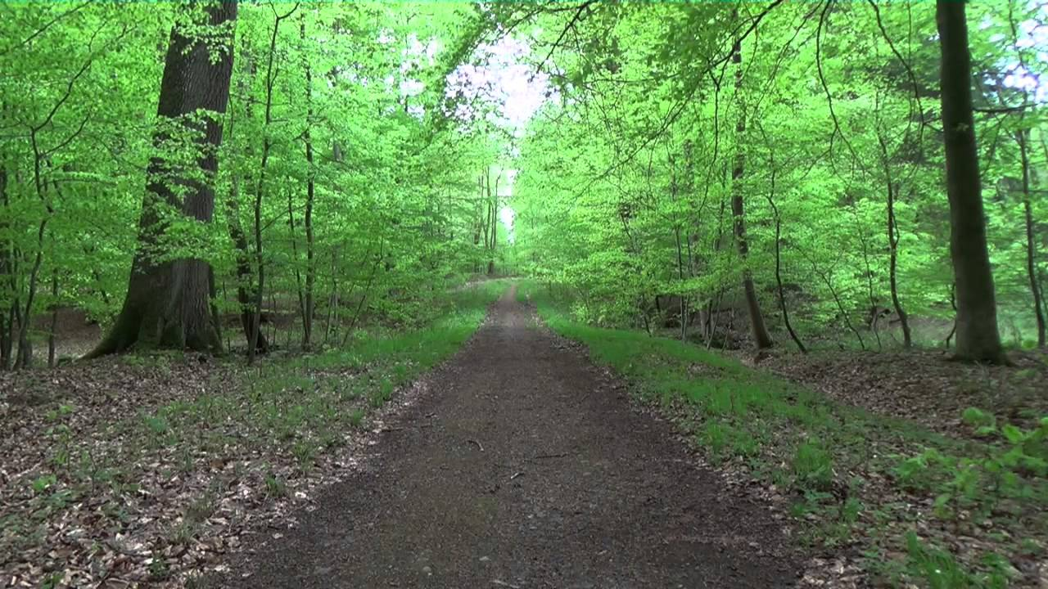

**Fig 2 : Forest without fire**

**2.4 METHODOLOGY**

Here we have used a Deep Learning technique – Convolutional Neural Network (CNN). We used this technique because it makes the task effectively and also it plays a core part in a regular Artificial Neural Network (ANN) with pre-processing. CNN is combination of Convolutional Layers and Neural Network. Basically, any Neural Network which is used for image processing, consist of following layer - Input layer, Convolutional Layer, Pooling Layer, Dense Layer.

**5**

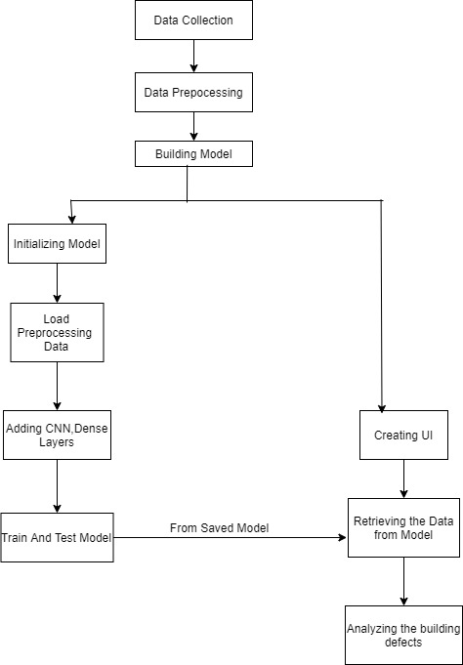

**Fig 3: Flowchart**

**6**

* + 1. **IMPORTING THE BUILDING LIBRARIES**

Importing the required libraries for our model. Where we are going to add different layers further like Dense, Convolution, Max pooling, Flatten. We will be defining our deep learning neural network using Keras packages. We import the Sequential, Dense, Dropout and Activation packages for defining the network architecture. We use load_model package for saving and retrieving our model.

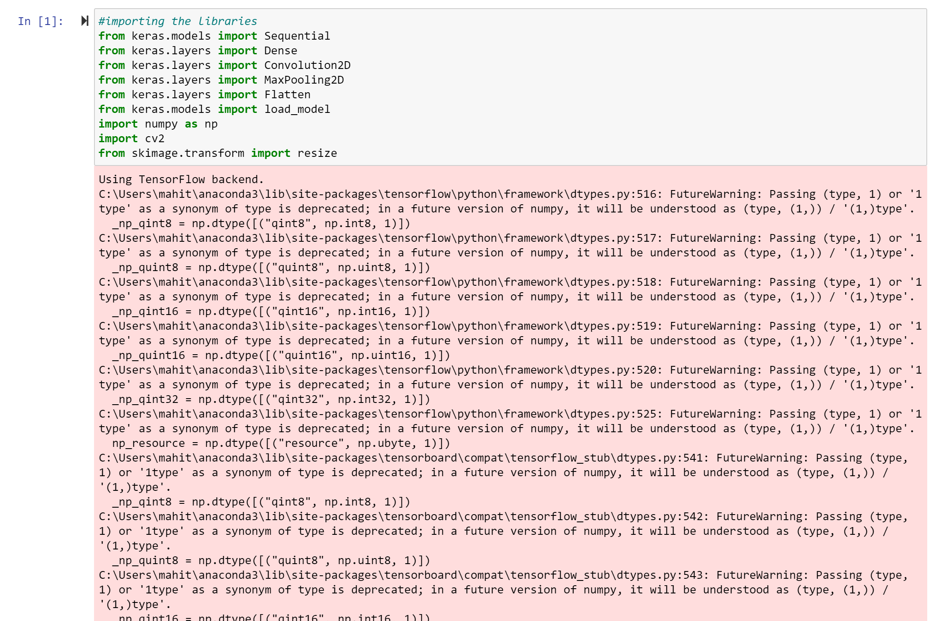

**Fig 4: Imported Libraries**

* + 1. **INITIALIZE THE MODEL**

There are two ways to build Keras models: **sequential**and functional *.* Here we are using sequential for our model. The **sequential** API allows you to create models layer-by-layer for most problems. It is limited in that it does not allow you to create models that share layers or have multiple inputs or outputs



**Fig5: Model Initialization**

7

* + 1. **ADDING CNN AND DENSE LAYERS**

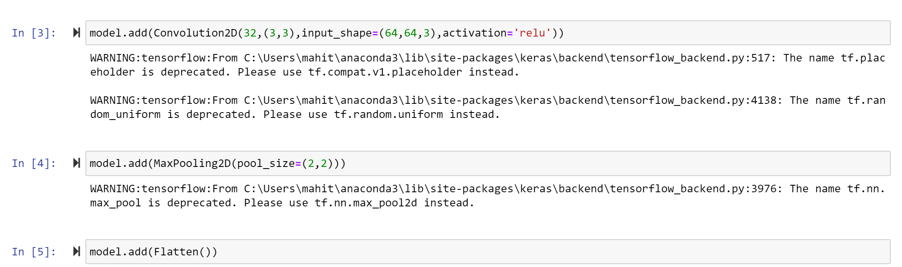

**Fig6: Convolution, Maxpooling, Flatten Layers**

**Convolution**: Convolution is performed on an image to identify certain features in an image. Convolution helps in blurring, sharpening, edge detection, noise reduction and more on an image that can help the machine to learn specific characteristics of an image.

**Pooling**: A convoluted image can be too large and therefore needs to be reduced. Pooling is mainly done to reduce the image without losing features or patterns.

**Flattening**: Flattening transforms a two-dimensional matrix of features into a vector of features that can be fed into a neural network or classifier.

Dense layer is the regular deeply connected neural network layer. It is most common and frequently used layer. Dense layer does the below operation on the input and return the output. In this we are going add hidden and output layers.

**8**

The arguments we used in dense layer are as follows

* input_shape represent the shape of input data.
* The keyword arguments used for passing initializations to layers will depend on the layer it is init.
* units represent the number of nodes in the layer.
* activation represents the activation function.
* Output_dim represents how many outputs needed.

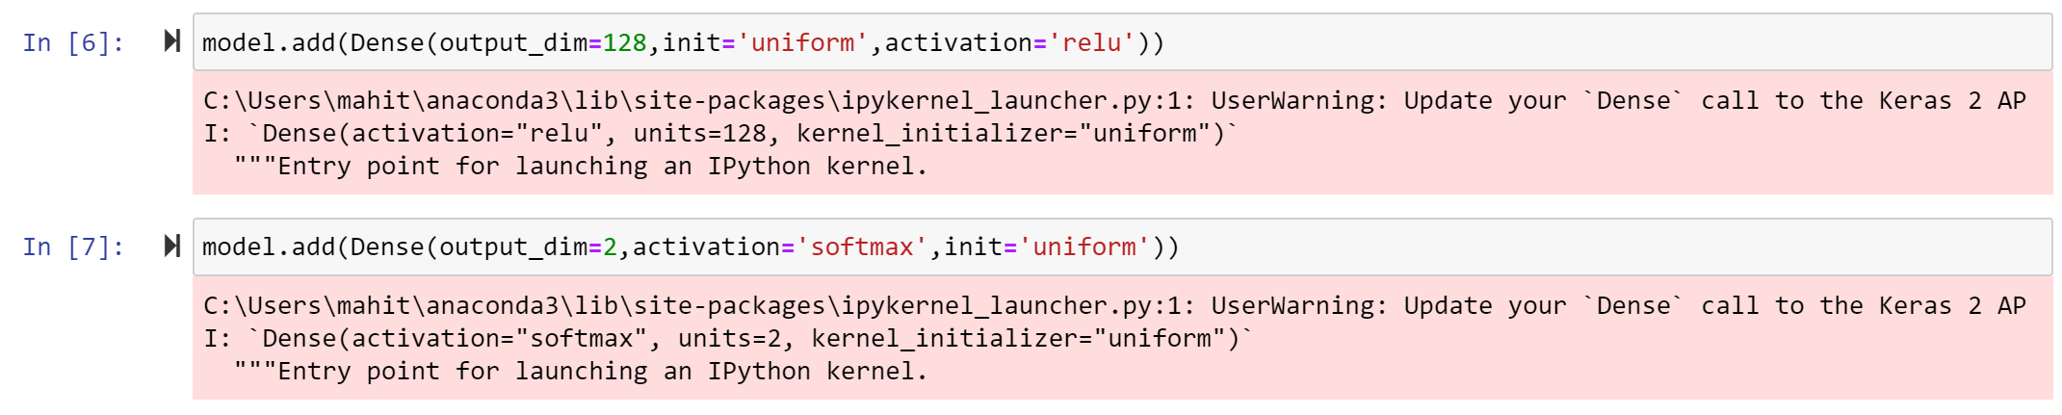

**Fig7: Applying dense layers**

Softmax Activation: The softmax activation function is used in neural networks when we want to **build a multi-class classifier** which solves the problem of assigning an instance to one class when the number of possible classes is more than two.

ReLU Activation: ReLU stands for Rectified Linear Unit. The main advantage of using this function over other activation functions is that it does not activate all the neurons at the same time. If we don’t know which activation function should be used then, using ReLU is a good choice.

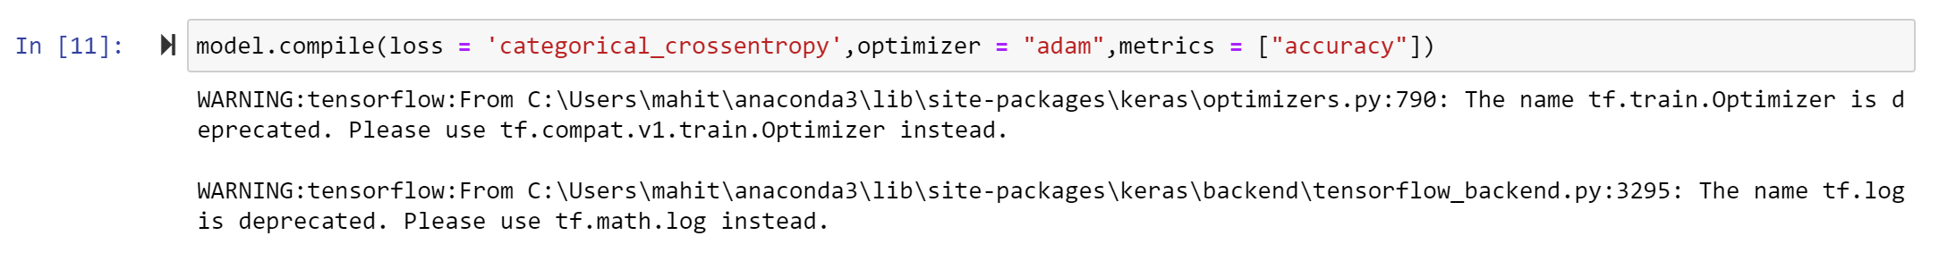

**Fig8: Compile**

Optimizer: Adam is used to provide an optimization algorithm that can handle on noisy problems. This also increases the accuracy.

**9**

Loss: We have two different types of cross entropy one is binary and the other is categorical. Binary **cross-entropy** is for binary classification, whereas **categorical cross entropy** is for multi-class classification.

Metrics: Metrics is a function just to know the performance of the model.

* + 1. **IMAGE PREPROCESSING**



**Fig9: Image Preprocessing**

Importing the required Libraries and then changing the images to one particular dimension

Arguments:

* rescale: Rescaling factor. Defaults to None. If None or 0, no rescaling is applied, otherwise we multiply the data by the value provided
* shear_range: Shear Intensity. Shear angle in a counter-clockwise direction in degrees.
* zoom_range: Range for random zooming of the image.
  + 1. **IMPORT DATASET**

Importing the dataset from our destination folder which contains two different classes of images forest with fire and forest without fire where we store in two different folders combined to one folder.

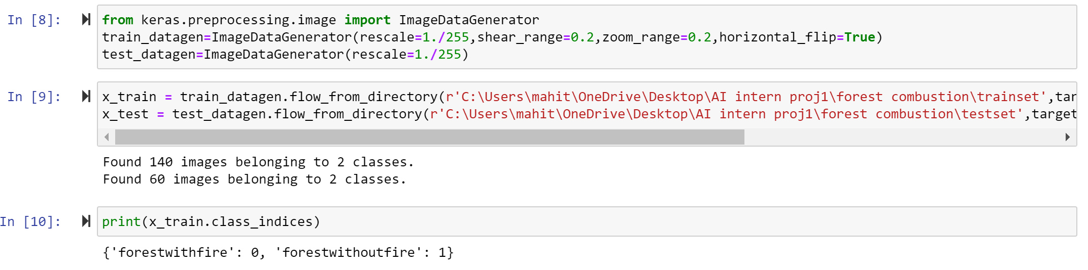

**Fig10: Imported Dataset**

**10**

Arguments:

* directory: Location of the x_train or x_test
* target_size: The dimensions to which all images found will be resized. Same as input size.
* Batch_size: Size of the batches of data (default: 32).
* Class_mode: Determines the type of label arrays that are returned. One of “categorical”, “binary”, “sparse”, “input”, or None.
  + 1. **TRAINING AND TESTING THE MODEL**

**Here we are training the model by fit_generator and later going to save the model. The arguments are as follows**

* generator: A generator sequence used to train the neural network (x_train).
* steps_per_epochs: Total number of steps (batches of samples) to yield from generator before declaring one epoch finished and starting the next epoch. It should typically be equal to the number of samples of your dataset divided by the batch size.
* epochs: Total number of epochs. One complete cycle of predictions of a neural network is called an epoch.
* Validation_data:  A generator sequence used to test and evaluate the predictions of the neural network (x_test).
* Validation_steps: Total number of steps (batches of samples) to yield from validation_data generator before stopping at the end of every epoch.

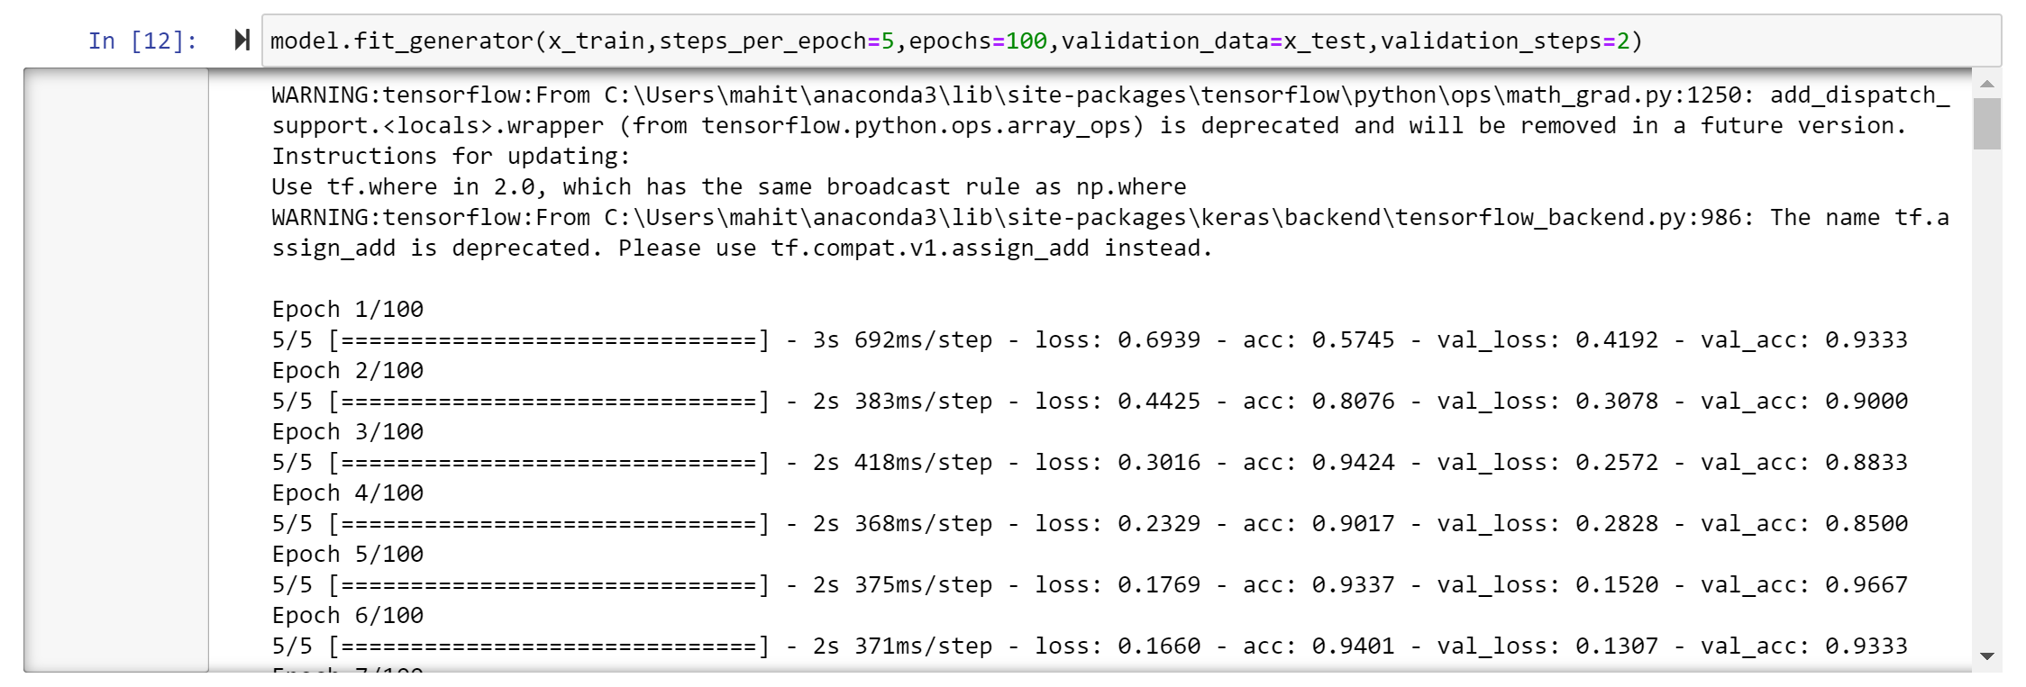 **11**

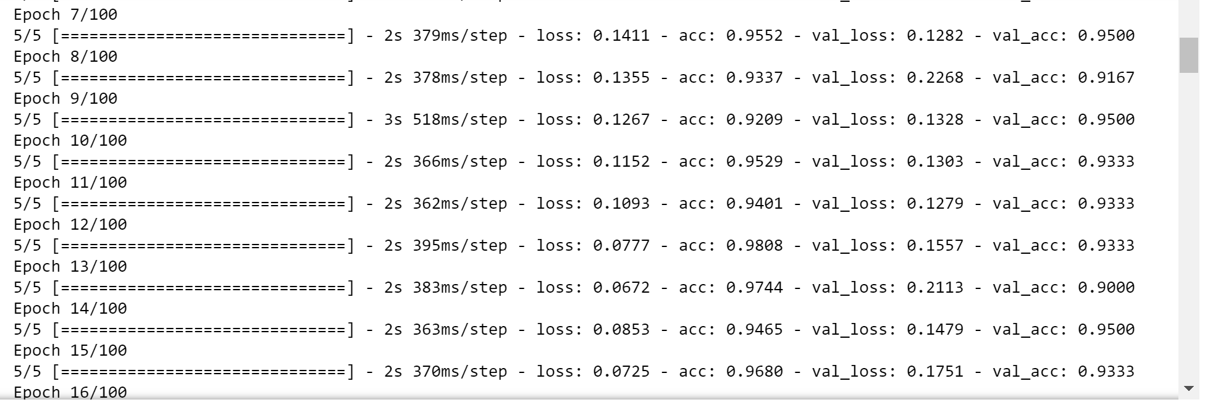

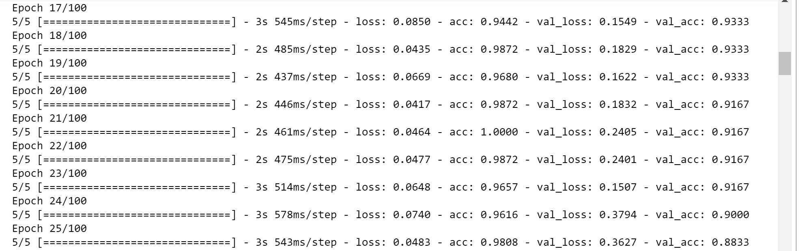

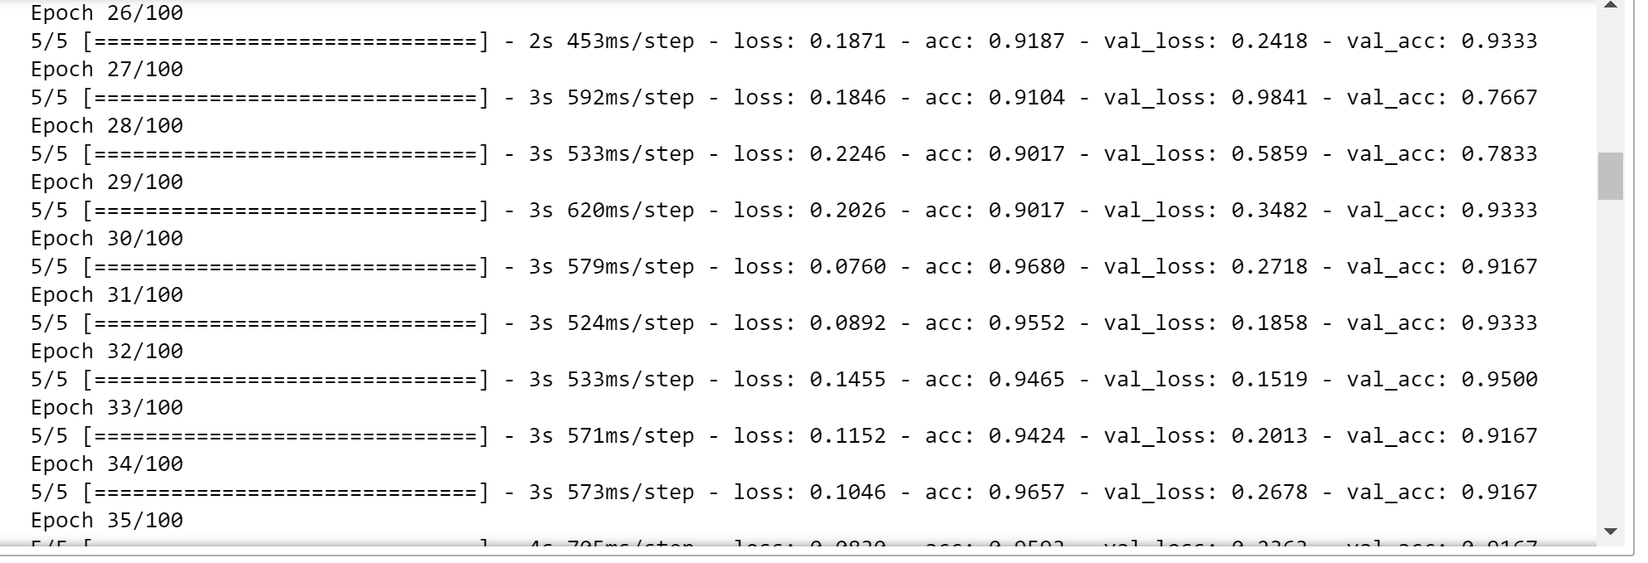

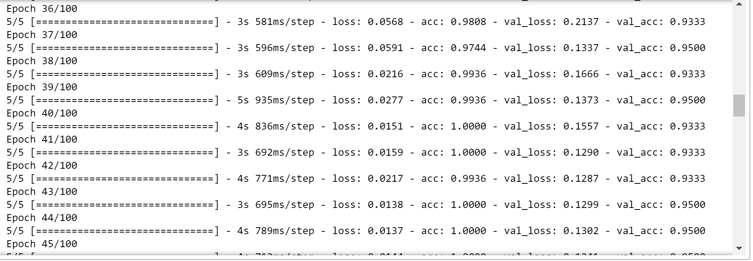

**12**

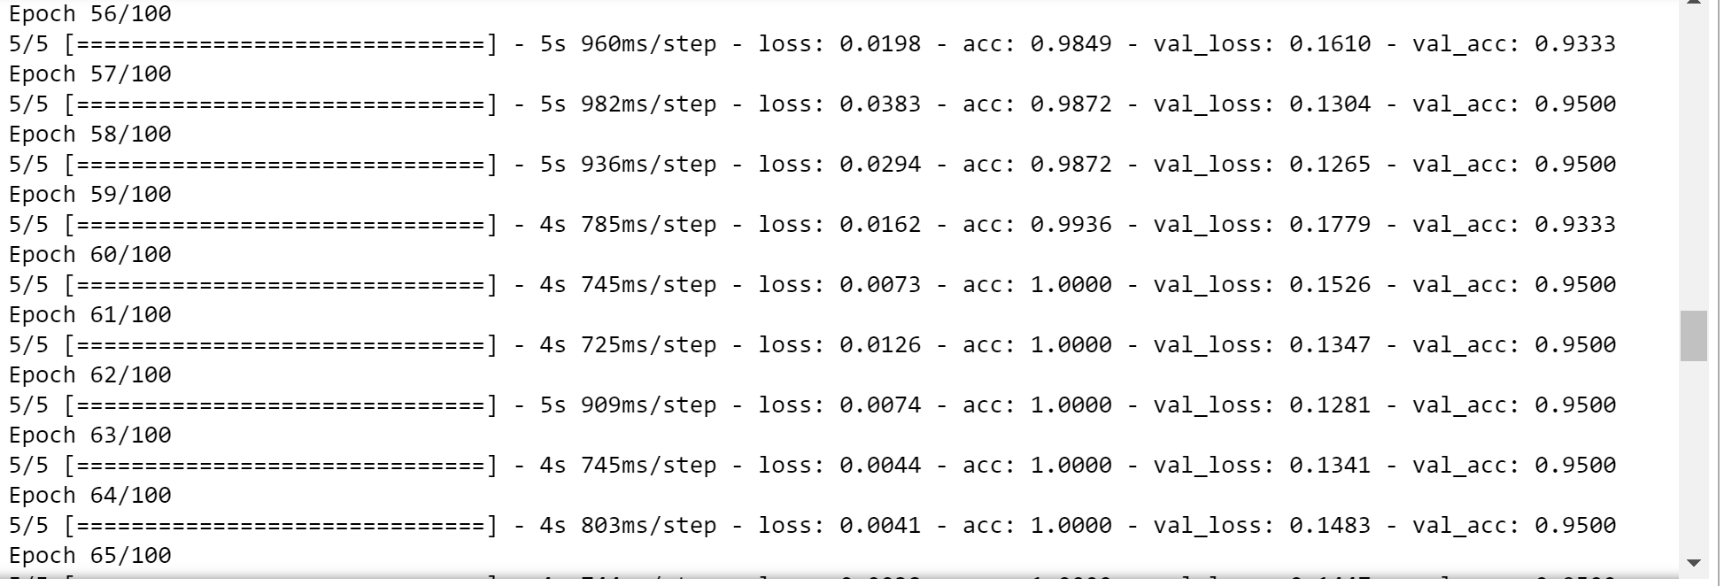

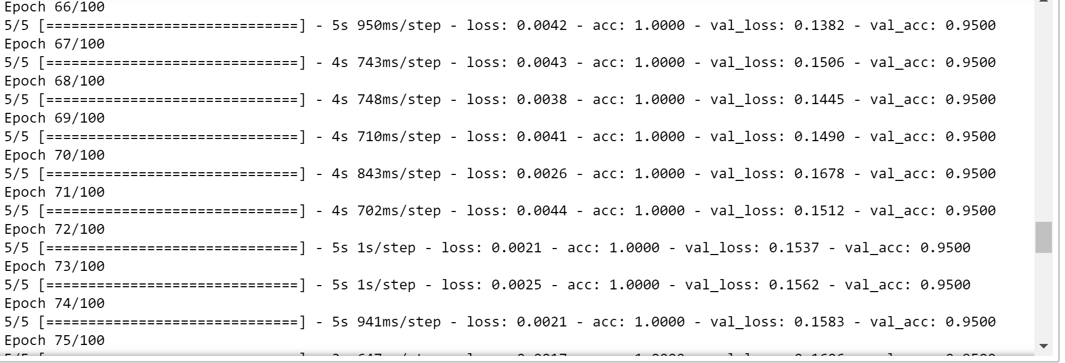

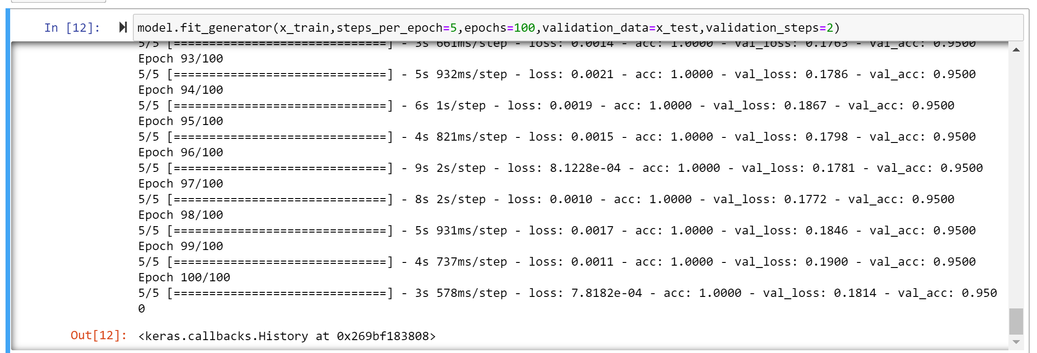

Accuracy when we train and test the model we got 95%

**Fig11: Training and Evaluating the model**

**13**

Next Here we need to optimize and save the model (.h5 – regressor file)



* + 1. **EXPERIMENTAL RESULTS**

When we give an image it predicts accurately and tell whether the given image is forest with fire or without fire and we also get an alarm sound if it recognizes the image as forest with fire.

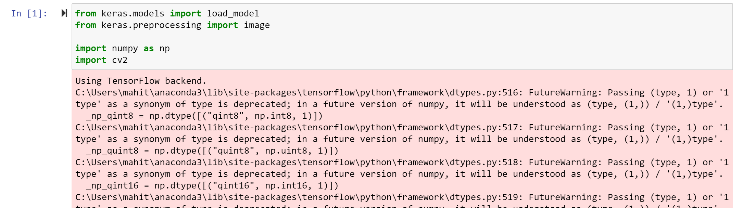

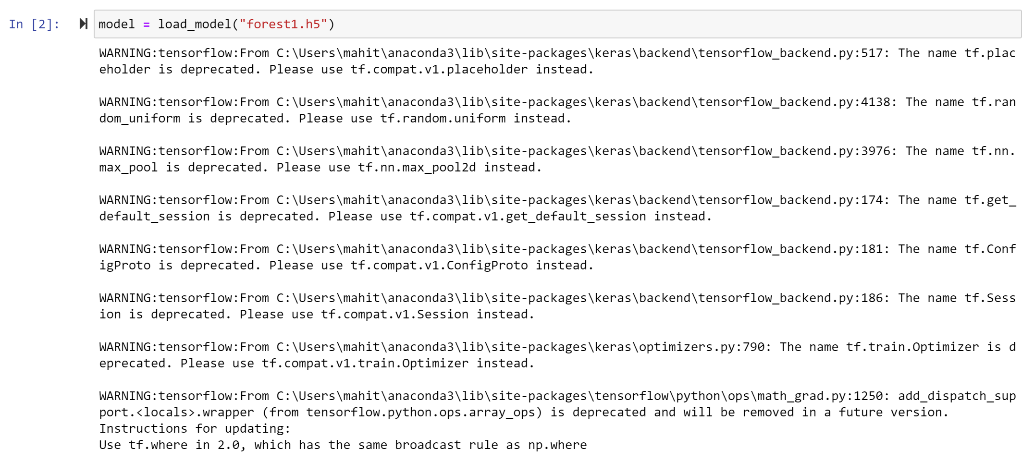

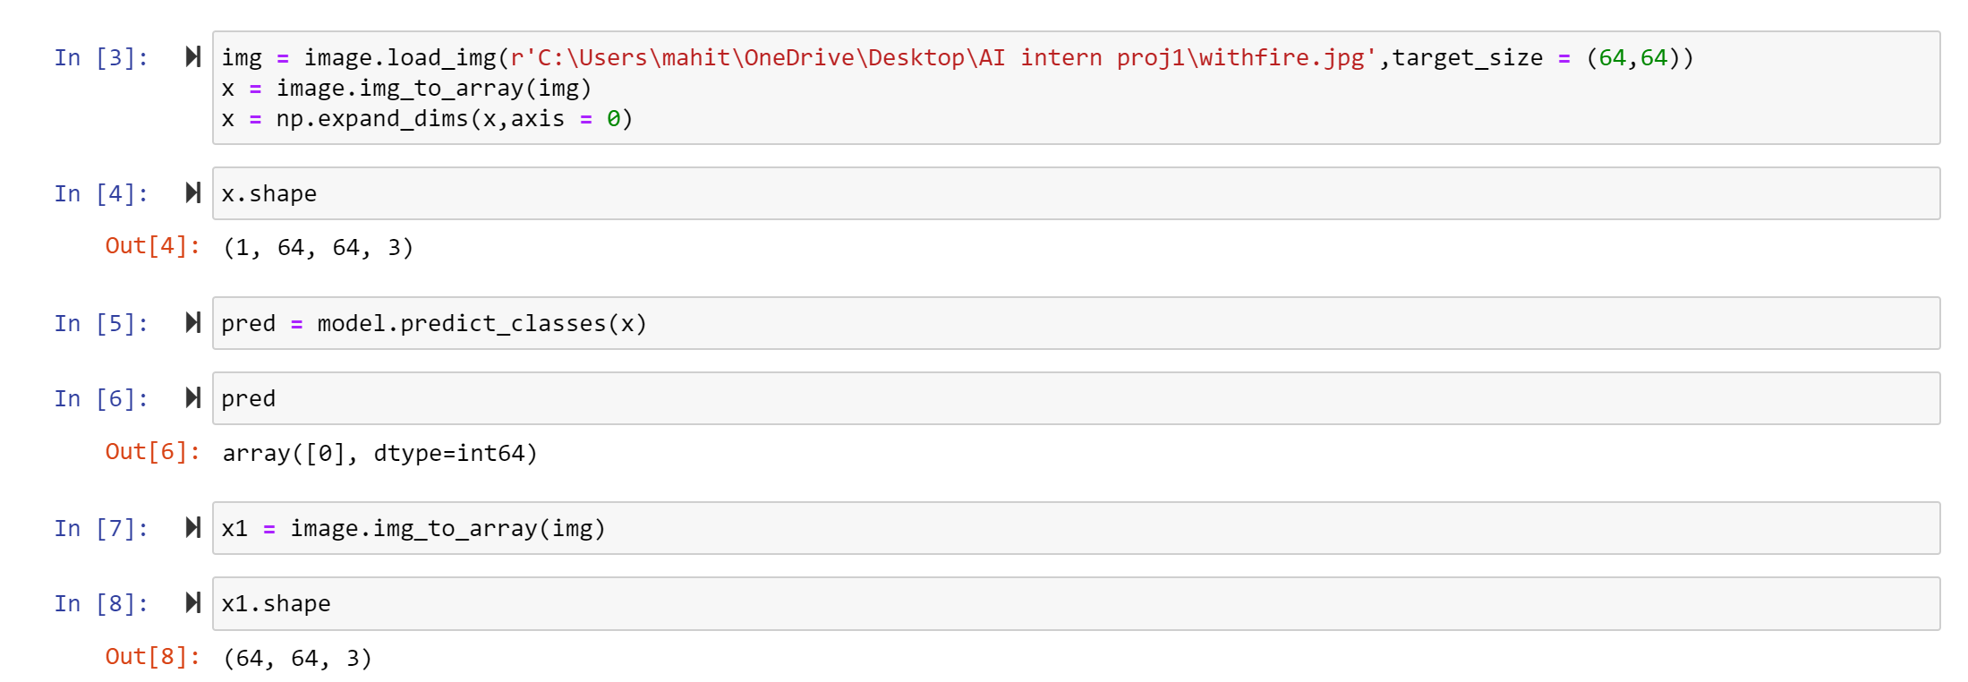

**Fig12: loading model and image**

**14**

**Result of alert alarm in jupyter Notebook**

It will predict as following different outputs, when we insert an image with fire we will get fire alarm in our system or it doesn’t produce any kind of sound in the system.

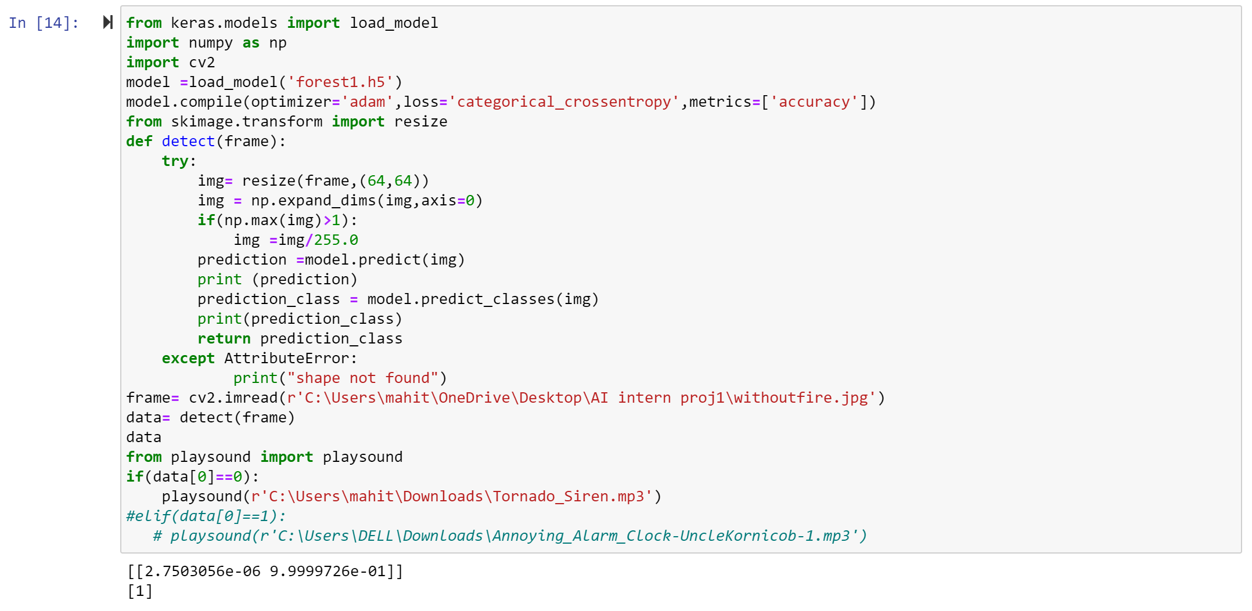

**Fig13: Without fire- Alarm off**

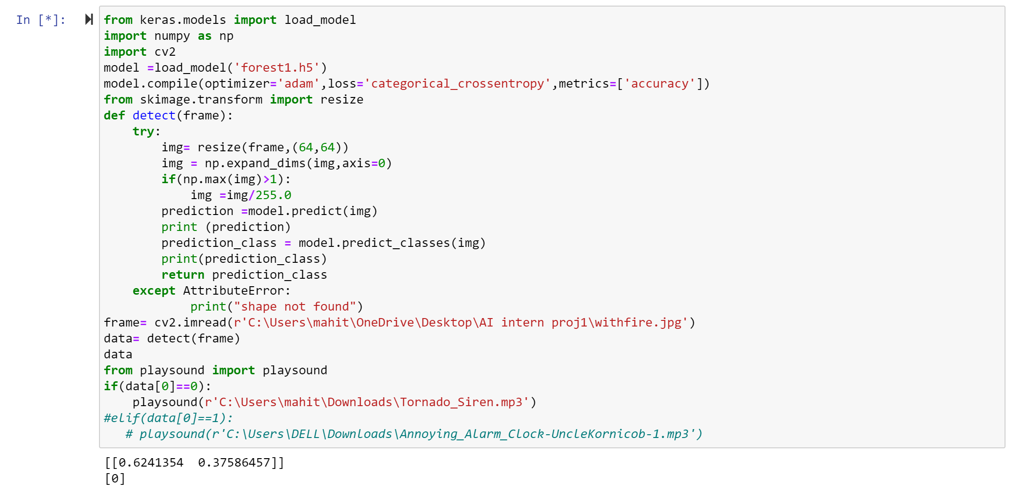 **Fig14: With fire -Alarm on**

**15**

**In loading the UI Page Anaconda Prompt is Used. Connects to the Server (localhost:5000)**

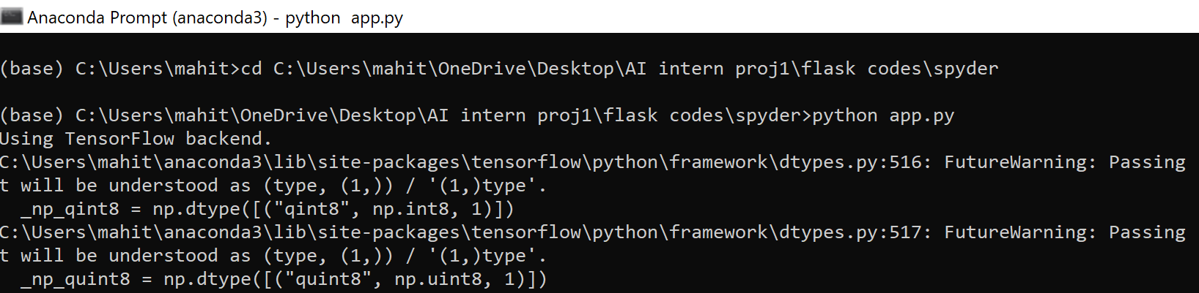

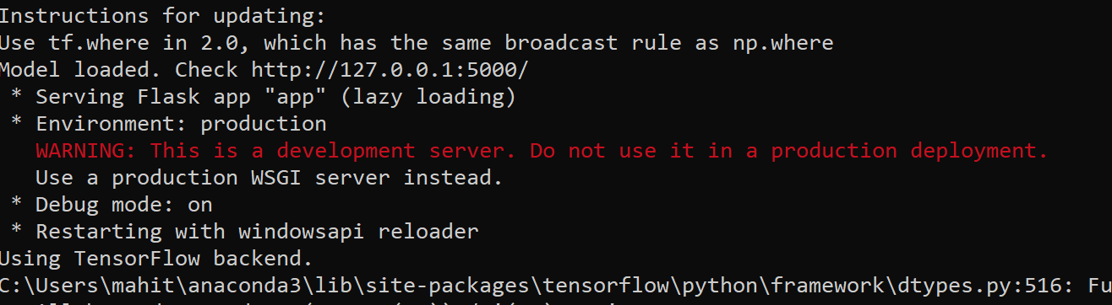

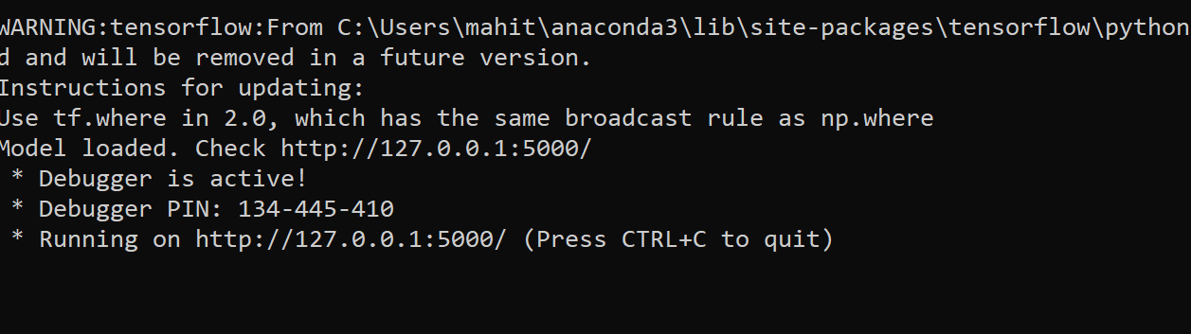

**Fig15: Anaconda Prompt**

**2.5 BUILDING USER INTERFACE FOR THE MODEL:**

We have created a user interface using a flak model. Flask is a web application framework written in Python. It has multiple modules that make it easier for a web developer to write applications without having to worry about the details like protocol management, thread management, etc.

Flask gives is a variety of choices for developing web applications and it gives us the necessary tools and libraries that allow us to build a web application.Two html pages are being used one is base and the other is index. This html pages are just to give user interface between user and the software.

**16**

Once you run the flask application we move on to the local host and able to insert the image from the destination. The image we take it is going to be stored in the upload folder. All the files have to be saved in one folder.

**Screenshots of what steps we have done during the model building include:**

**Data Collection – Create Train and Test Folders**

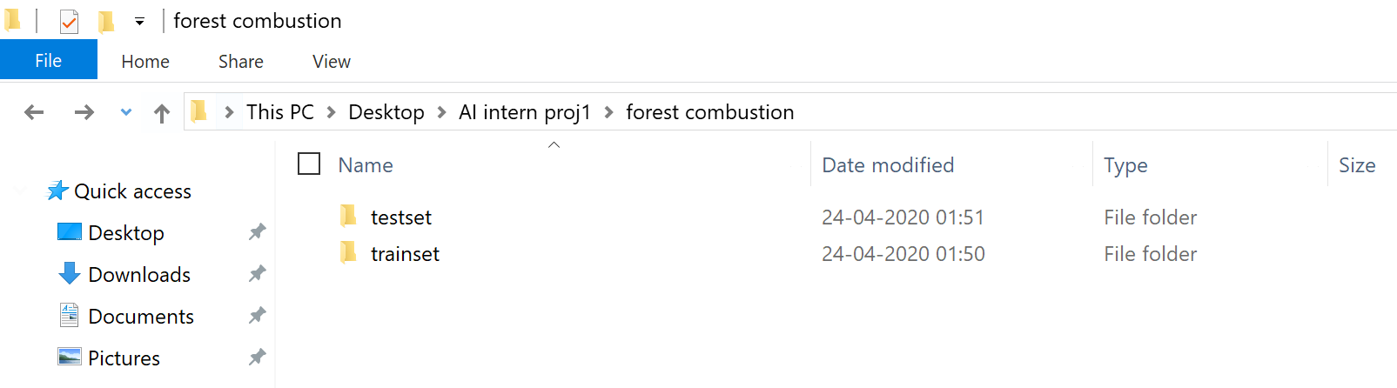

**Flask folder -**

Steps to be followed:

Create a main folder (spyder)

In that main folder create template folder and in that place .html file (base.html)

And create two folders static (contain css and jss) and uploads (images of prediction)

.py file (app.py) should be saved in that main folder

.h5 file (forest1.h5) which is downloaded from jupyter notebook should also be saved in main folder.

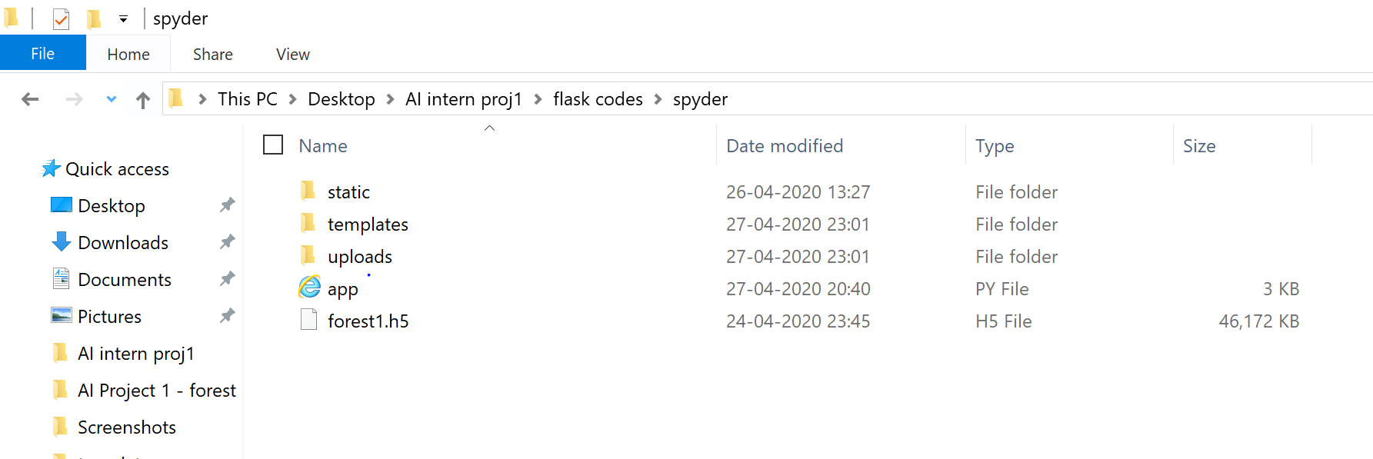

**Fig16: Folder of Flask model**

**17**

Static is to store some CSS and JS files we want to use for our web application. Templates is to store both the index, base html files. Upload is going to store when the user takes a image. App is going store the bellow code which connects the html files and stores the model. Building is the .h5 file where we saved our model in the python.

**app.py**

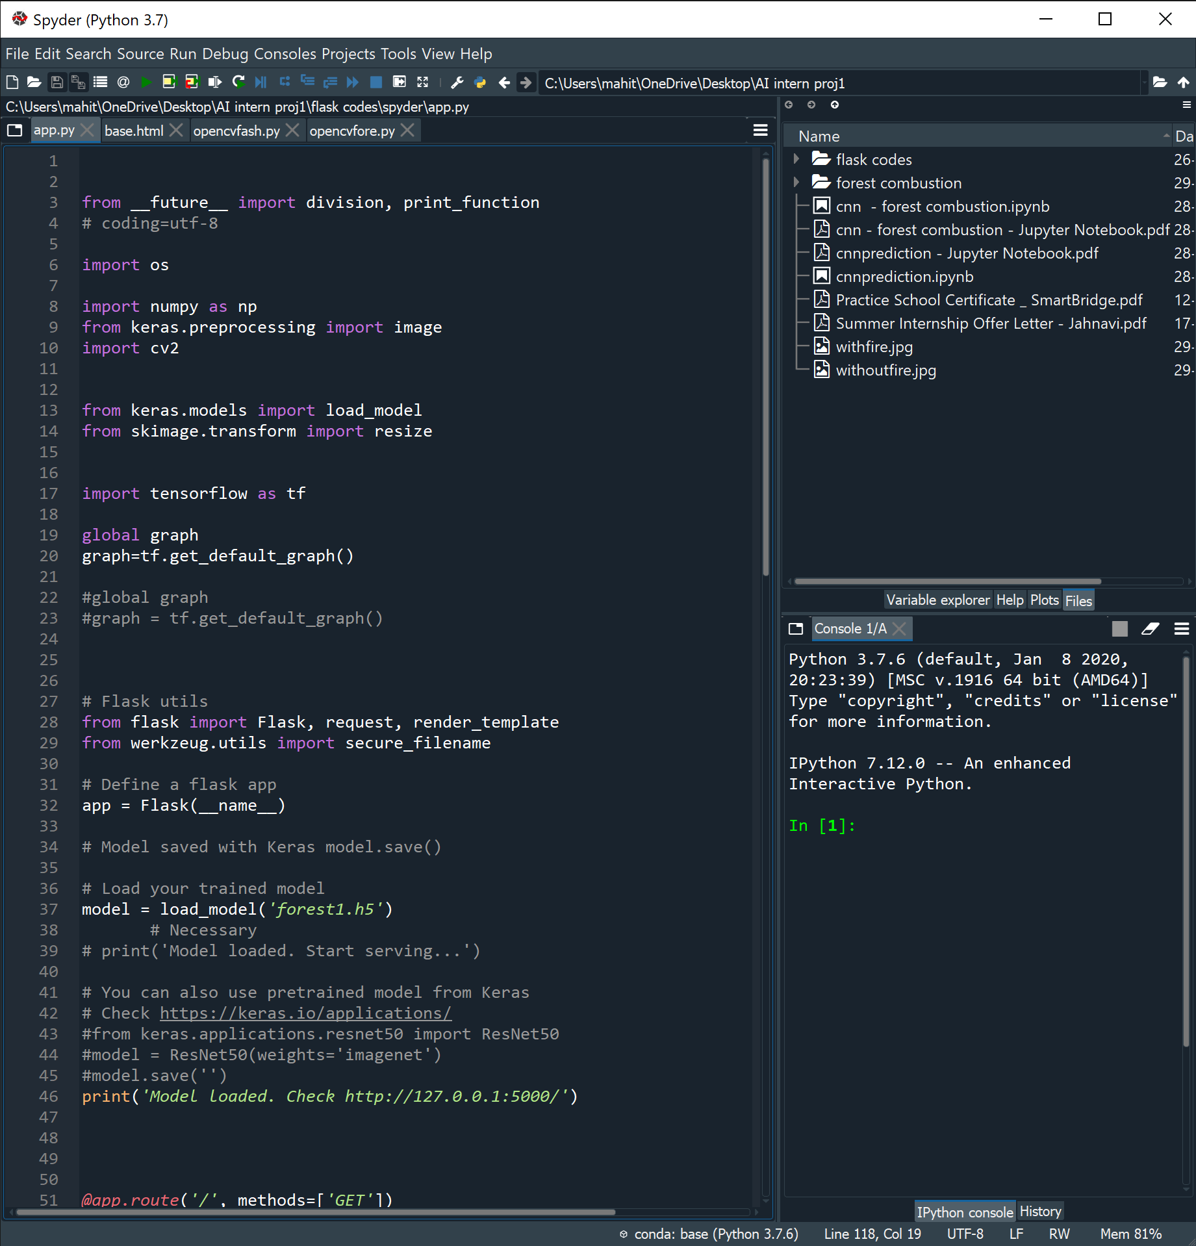

**Fig17: Flask Code**

**18**

**base.html**

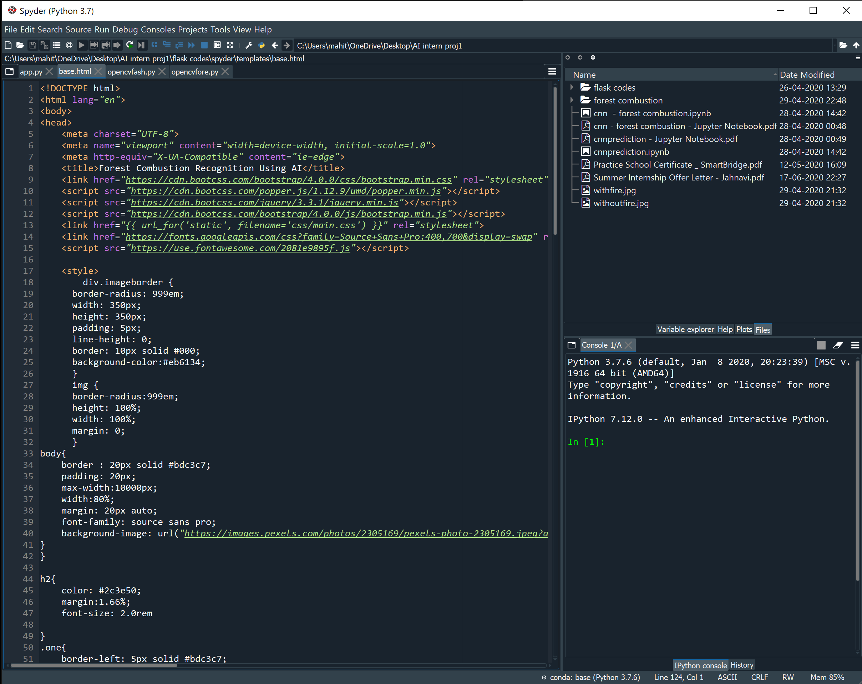

**Fig 18: html code**

**19**

**2.5.1 PREDICTION:**

As a result, when we uploaded an image by choosing it we will get the predict button then after clicking that the model will predict whether it is forest with fire or without fire.

This is the UI which was developed by using HTML and python linked with each other.

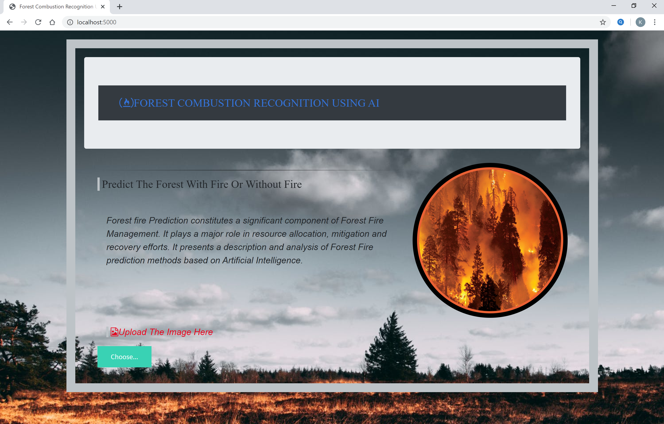

**Fig19: Developed UI**

**20**

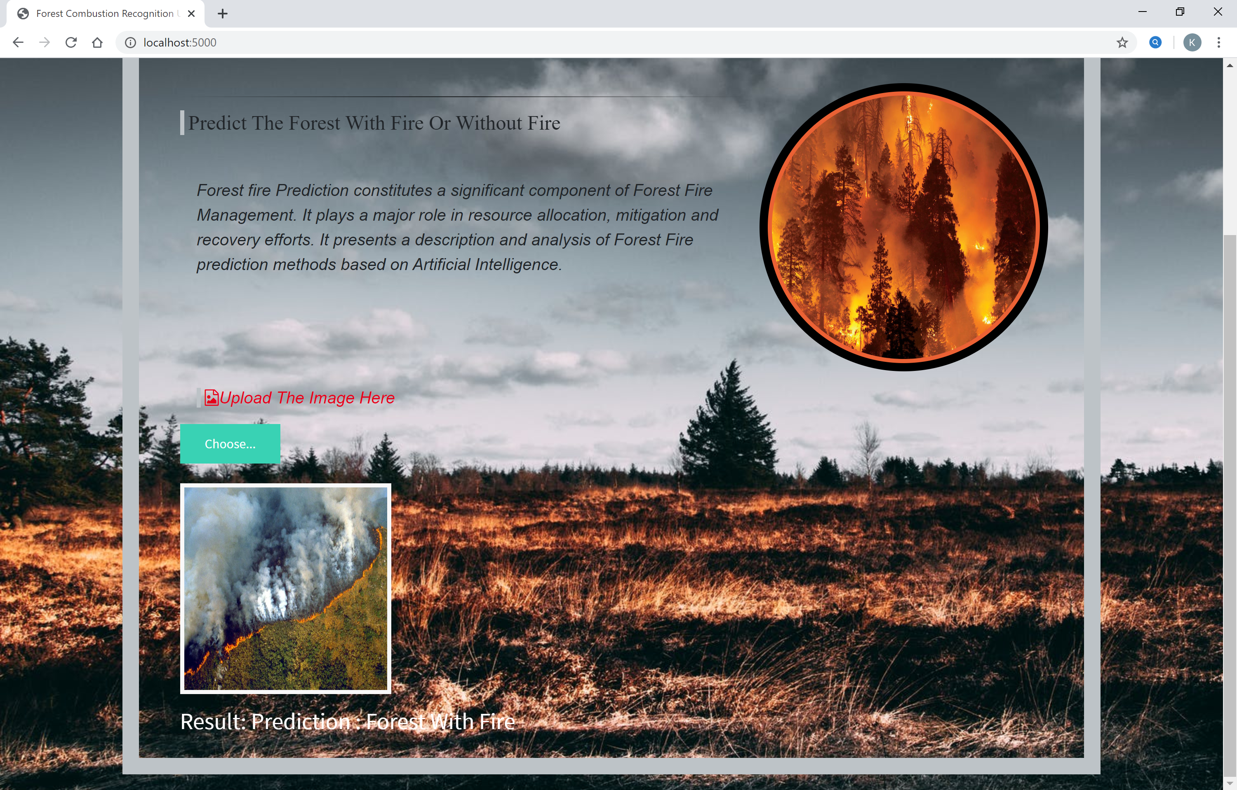

**Fig20: Prediction of Forest With Fire**

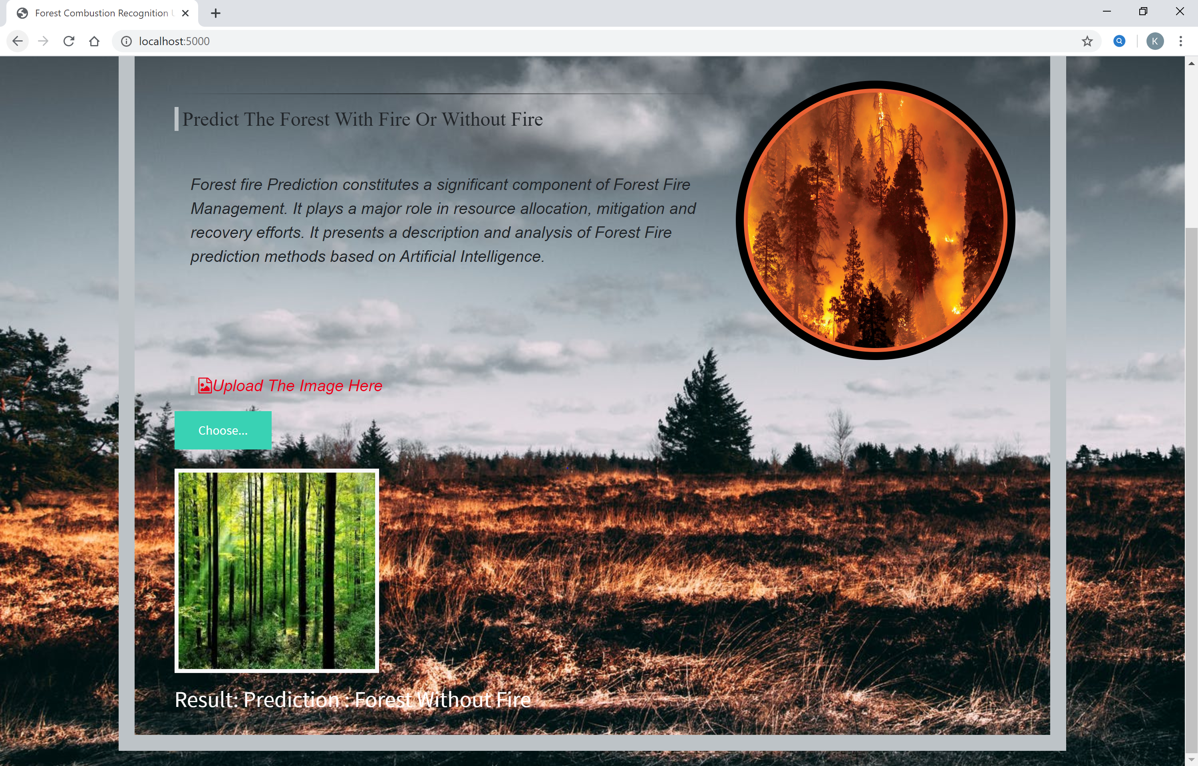

**Fig21: Prediction of Forest Without Fire**

The predicted outcome is displayed below the image

**21**

**OpenCV**

OpenCV (Open Source Computer Vision Library) is an open source computer vision and machine learning software library. OpenCV was built to provide a common infrastructure for computer vision applications and to accelerate the use of machine perception in the commercial products.

By using OpenCV we can open the camera and it can be able to predict whether the forest is with fire or without fire.

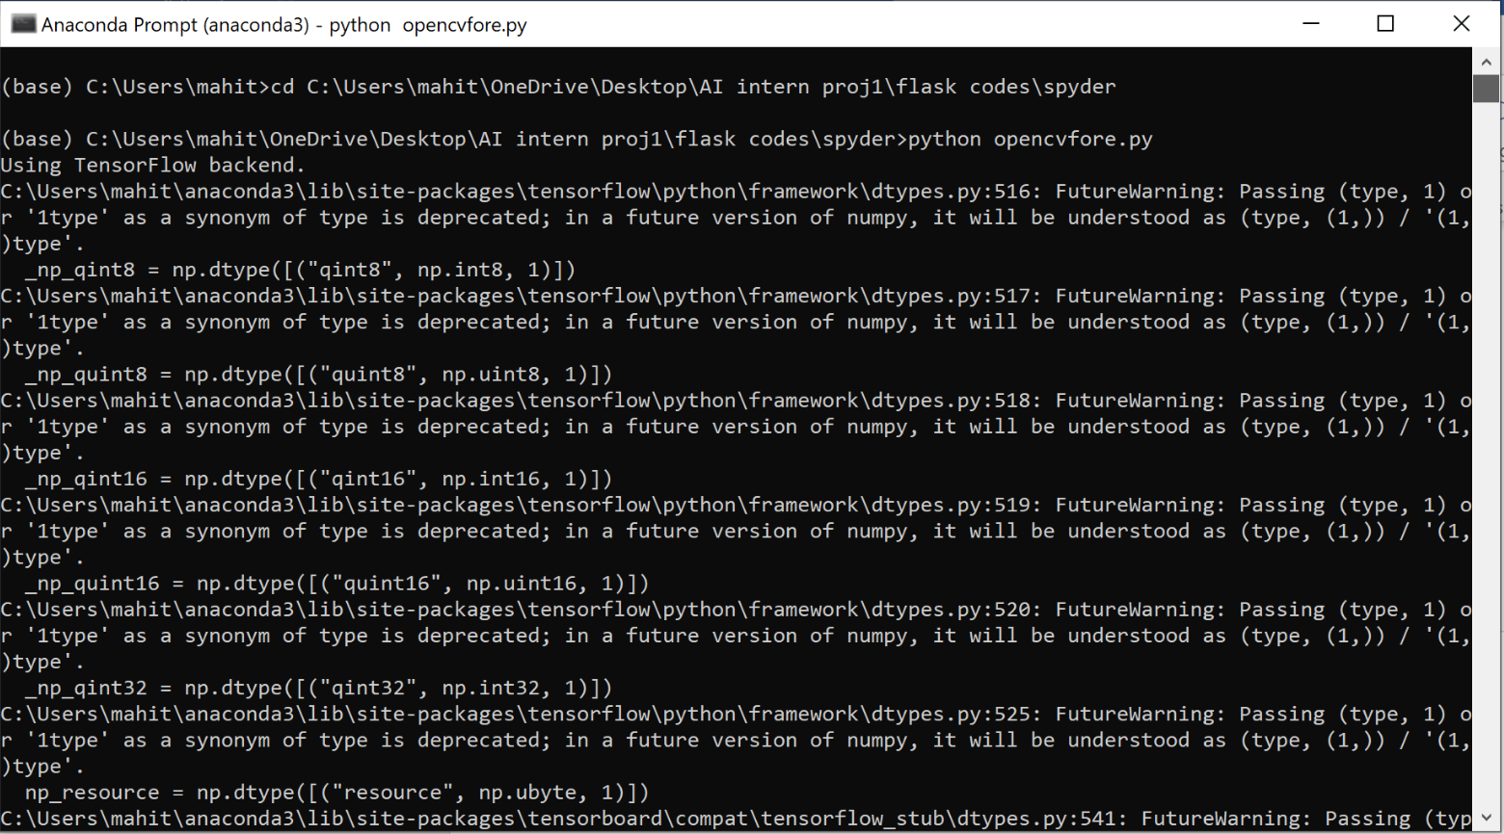

**Fig 22 : anaconda prompt – OpenCV**

**22**

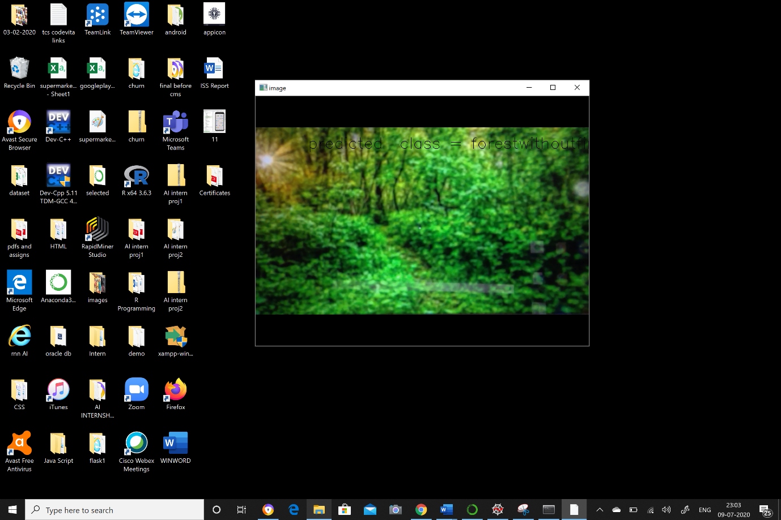

**Fig 23 : predicted class – without fire**

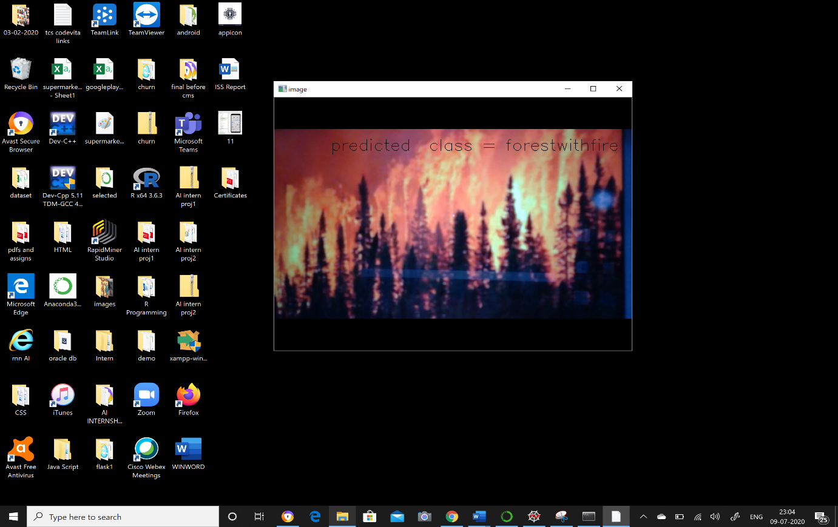

**Fig 24 : predicted class – with fire**

**23**

**Chapter – 3**

**THEORITICAL ANALYSIS**

**3.1 Block diagram**

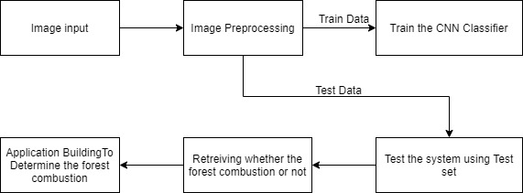

**Fig 25 : block diagram**

**3.2 Hardware/Software designing**

**Hardware**

1) A laptop / computer

2) 8-GB RAM

3) 32-GB ROM

4) 64 Bit

**Software**

***Front End:***

1. HTML

***Back End:***

Python – We use following GUI’s

1. ( Anaconda Navigator -> Jupyter Notebook, Spyder ) it is a desktop GUI
2. Anaconda Prompt

**24**

**APPENDIX**

**CODE**

**CNN CODE (Jupyter notebook)**

#importing the libraries

from keras.models import Sequential

from keras.layers import Dense

from keras.layers import Convolution2D

from keras.layers import MaxPooling2D

from keras.layers import Flatten

from keras.models import load_model

import numpy as np

import cv2

from skimage.transform import resize

model = Sequential()

model.add(Convolution2D(32,(3,3), input_shape = (64,64,3), activation = 'relu'))

model.add(MaxPooling2D(pool_size = (2,2)))

model.add(Flatten())

model.add(Dense(units = 128, init ='uniform', activation ='relu'))

model.add(Dense(units = 128, init ='uniform', activation ='relu'))

model.add(Dense(output_dim = 2, activation = 'softmax', init ='uniform'))

model.compile(optimizer='adam',loss='categorical_crossentropy',metrics=['accuracy'])

from keras.preprocessing.image import ImageDataGenerator

train_datagen = ImageDataGenerator(rescale = 1./255, shear_range = 0.2, zoom_range = 0.2, horizontal_flip = True)

test_datagen = ImageDataGenerator(rescale = 1./255)

x_train = train_datagen.flow_from_directory(r'C:\Users\mahit\OneDrive\Desktop\AI intern proj1\forest combustion\trainset',target_size = (64,64),batch_size = 32,class_mode = 'categorical')

**25**

x_test = test_datagen.flow_from_directory(r'C:\Users\mahit\OneDrive\Desktop\AI intern proj1\forest combustion\testset',target_size = (64,64),batch_size = 32,class_mode = 'categorical')

print(x_train.class_indices)

model.compile(loss= 'categorical_crossentropy',optimizer = "adam",metrics = ["accuracy"])

model.fit_generator(x_train,steps_per_epoch=5,epochs=100,validation_data=x_test,validation_steps=2)

model.save("forest1.h5")

**app.py code**

from __future__ import division, print_function

# coding=utf-8

import os

import numpy as np

from keras.preprocessing import image

import cv2

from keras.models import load_model

from skimage.transform import resize

import tensorflow as tf

global graph

graph=tf.get_default_graph()

#global graph

#graph = tf.get_default_graph()

# Flask utils

from flask import Flask, request, render_template

from werkzeug.utils import secure_filename

from gevent.pywsgi import WSGIServer

# Define a flask app

app = Flask(__name__)

# Model saved with Keras model.save()

**26**

# Load your trained model

model = load_model('forest1.h5')

# Necessary

# print('Model loaded. Start serving...')

# You can also use pretrained model from Keras

# Check https://keras.io/applications/

#from keras.applications.resnet50 import ResNet50

#model = ResNet50(weights='imagenet')

#model.save('')

print('Model loaded. Check http://127.0.0.1:5000/')

@app.route('/', methods=['GET'])

def index():

# Main page

return render_template('base.html')

@app.route('/predict', methods=['GET', 'POST'])

def upload():

if request.method == 'POST':

# Get the file from post request

f = request.files['image']

# Save the file to ./uploads

basepath = os.path.dirname(__file__)

file_path = os.path.join(

basepath, 'uploads', secure_filename(f.filename))

f.save(file_path)

img = image.load_img(file_path, target_size=(64, 64))

x = image.img_to_array(img)

x = np.expand_dims(x, axis=0)

with graph.as_default():

preds = model.predict_classes(x)

#preds = [0]

#type(preds)

#print(preds[0])

#print("prediction",preds)

**27**

index = ['Forest With Fire','Forest Without Fire']

#text = index[0]

#print(text)

text = "Prediction : "+index[preds[0]]

# ImageNet Decode

return text

from keras.models import load_model

model =load_model('forest1.h5')

model.compile(optimizer='adam',loss='categorical_crossentropy',metrics=['accuracy'])

def detect(frame):

try:

img= resize(frame,(64,64))

img = np.expand_dims(img,axis=0)

if(np.max(img)>1):

img =img/255.0

prediction =model.predict(img)

print (prediction)

prediction_class = model.predict_classes(img)

print(prediction_class)

return prediction_class

except AttributeError:

print("shape not found")

if __name__ == '__main__':

app.run(debug = True,threaded = False)

frame= cv2.imread(r'C:\Users\mahit\OneDrive\Desktop\AI intern proj1\withfire.jpg')

data= detect(frame)

data

from playsound import playsound

if(data[0]==0):

playsound(r'C:\Users\mahit\Downloads\Tornado_Siren.mp3')

#elif(data[0]==1):

#playsound(r'C:\Users\DELL\Downloads\Annoying_Alarm_Clock-UncleKornicob-1.mp3')

**28**

**base.html**

<!DOCTYPE html>

<html lang="en">

<body>

<head>

<meta charset="UTF-8">

<meta name="viewport" content="width=device-width, initial-scale=1.0">

<meta http-equiv="X-UA-Compatible" content="ie=edge">

<title>Forest Combustion Recognition Using AI</title>

<link href="https://cdn.bootcss.com/bootstrap/4.0.0/css/bootstrap.min.css" rel="stylesheet">

<script src="https://cdn.bootcss.com/popper.js/1.12.9/umd/popper.min.js"></script>

<script src="https://cdn.bootcss.com/jquery/3.3.1/jquery.min.js"></script>

<script src="https://cdn.bootcss.com/bootstrap/4.0.0/js/bootstrap.min.js"></script>

<link href="{{ url_for('static', filename='css/main.css') }}" rel="stylesheet">

<link href="https://fonts.googleapis.com/css?family=Source+Sans+Pro:400,700&display=swap" rel="stylesheet" >

<script src="https://use.fontawesome.com/2081e9895f.js"></script>

<style>

div.imageborder {

border-radius: 999em;

width: 350px;

height: 350px;

padding: 5px;

line-height: 0;

border: 10px solid #000;

background-color:#eb6134;

}

img {

border-radius:999em;

height: 100%;

width: 100%;

**29**

margin: 0;

}

body{

border : 20px solid #bdc3c7;

padding: 20px;

max-width:10000px;

width:80%;

margin: 20px auto;

font-family: source sans pro;

background-image: url("https://images.pexels.com/photos/2305169/pexels-photo-2305169.jpeg?auto=compress&cs=tinysrgb&dpr=2&h=650&w=940");

}

}

h2{

color: #2c3e50;

margin:1.66%;

font-size: 2.0rem

}

.one{

border-left: 5px solid #bdc3c7;

font-size: 25px;

<!--color: #ffbf00;-->

color: #000000;

font-family: Aharoni;

padding-left: 5px;

}

.date{

color: #3498db;

margin:1.66%;

letter-spacing: 0.2rem;

**30**

}

p{

margin:1.66%;

}

hr{

border: 0;

height: 1px;

background-image: linear-gradient(to right, rgba(0, 0, 0, 0), rgba(0, 0, 0, 0.75), rgba(0, 0, 0, 0));

}

.post{

margin:20px;

}

h1{

color: #3474db;

margin:1.66%;

font-size: 1.3rem;

font-family:Arial Black Web Safe Font;

text-align: right;

}

h1.two{

color: #3474db;

font-size: 25px;

font-family:Arial Black Web Safe Font;

text-align: right;

}

.post{

font-size: 20px;

font-style: oblique;

font-family: sans-serif

margin:20px;

}

**31**

#result {

color: #FFFFFF;

}

p.big {

line-height: 1.8;

}

.lg

{

color: #3474db;

}

.three

{

color: #e6001a;

}

.upload-labe one

{

color: #e6001a;

}

</style>

</head>

<!--<source src=r"C:\Users\mahit\Downloads\Tornado_Siren.mp3" type="audio/mp3">-->

<div class="jumbotron">

<nav class="navbar navbar-expand-lg navbar-light bg-dark">

<div class="container">

<h1 class="two" ><i class="fa fa-free-code-camp fa lg" aria-hidden="true"></i>FOREST COMBUSTION RECOGNITION USING AI

</h1>

</div>

</div>

</nav>

<div class="container">

<div id="content" style="margin-top:2em">

<div class="container"

**32**

<div class="row">

<div class="col-sm-8 bd" >

<!--<div><h3 class="one"> Forest Combustion Recognition </h3></div>-->

<hr>

<h3 class="one"> Predict The Forest With Fire Or Without Fire </h3>

<br>

<p class="post">Forest fire Prediction constitutes a significant component of Forest Fire Management. It plays a major role in resource allocation, mitigation and recovery efforts. It presents a description and analysis of Forest Fire prediction methods based on Artificial Intelligence.</p>

</div>

<div class="imageborder" >

<imgsrc="https://magazine.columbia.edu/sites/default/files/styles/wysiwyg_full_width_image/public/2018-09/Wild-fires.jpg?itok=pBKjTId4"height="350" width="350" alt="iceland" >

</div>

<div class="col-sm-5">

<div>

<h4 class="one post three" ><i class="fa fa-file-image-o" aria-hidden="true">

</i>Upload The Image Here </h4>

<form action = "http://localhost:5000/" id="upload-file" method="post" enctype="multipart/form-data">

<label for="imageUpload" class="upload-label">

Choose...

</label>

<input type="file" name="image" id="imageUpload" accept=".png, .jpg, .jpeg">

</div>

<hr>

</form>

</div>

<div class="image-section" style="display:none;">

**33**

<div class="img-preview">

<div id="imagePreview">

</div>

</div>

<div>

<button type="button" class="btn btn-info btn-lg " id="btn-predict">Predict!</button>

<!--<audio src=r"C:\Users\mahit\Downloads\Tornado_Siren.mp3" controls>-->

</audio>

</div>

</div>

<div class="loader" style="display:none;"></div>

<h3>

<span id="result"> </span>

</h3></div>

</div>

</div>

</div>

</div>

</div>

</body>

<footer>

<script src="{{ url_for('static', filename='js/main.js') }}" type="text/javascript"></script>

</footer>

</body>

</html>

**34**

**Opencvfore.py**

import cv2

#import facevec

import numpy as np

from keras.preprocessing import image

from keras.models import load_model

model = load_model('forest1.h5')

video = cv2.VideoCapture(0)

name = ["forestwithfire","forestwithoutfire"]

while(1):

success, frame = video.read()

cv2.imwrite("image.jpg",frame)

img = image.load_img("image.jpg",target_size = (64,64))

x = image.img_to_array(img)

x = np.expand_dims(x,axis = 0)

pred = model.predict_classes(x)

p = pred[0]

print(pred)

cv2.putText(frame, "predicted class = "+str(name[p]), (100,100), cv2.FONT_HERSHEY_SIMPLEX, 1, (0,0,0), 1)

cv2.imshow("image",frame)

if cv2.waitKey(1) & 0xFF == ord('a'):

break

video.release()

cv2.destroyAllWindows()

**35**

**Chapter-4**

**4.1 CONCLUSION**

We developed this project using AI, Deep learning techniques (CNN), python3. This study proposes an effective forest fire detection method using image processing techniques. The algorithm uses Train and test model. It will train our model and further it test whether fire is present or not. Five fire detection rules are applied to detect the fire. The performance of the proposed algorithm is tested on data set consisting of various pictures of forest collected from Internet, 100 of which were actual fire pictures , while another 100 were without fire .The results show that the proposed algorithm achieves good detection rates. These results indicate that the proposed method is accurate and can be used in automatic forest fire-alarm systems.

**4.2 FUTURE SCOPE**

The vital requirements of an autonomous early forest combustion recognition system, its main modules and methods for wildfire management and risk assessment, smoke and combustion detection, it have been done based on images. We have trained and tested the model got the accuracy of 95% and got the alarm sound in Jupyter Notebook. Further we wanted to develop our UI linked to the html page by getting the alarm in our system and make our model to run more rapidly and accurately.

**4.3 REFERENCES**

Anon, 1995. Report of the Committee of Enquiry into Forest Fires in Himachal Pradesh and Uttar Pradesh in 1995, Government of India.

Bahuguna, V.K. and Upadhyay, A., 2002. Forest fires in India: Policy initiatives for community participation; International Forestry Review, 4(2).

FAO, 2003.Wildland Fire Management Terminology. FAO Forestry Paper 70. FAO, Rome.

<https://www.researchgate.net/publication/261272818_Artificial_intelligence_for_forest_fire_prediction>

<https://ieeexplore.ieee.org/document/5695809/metrics#metrics>

**36**